Cyclistic Bike Share Analysis

Scenario:

Cyclistic is a bike-share company in Chicago. In 2016, Cyclistic launched a successful bike-share offering. Since then, the program has grown to a fleet of 5,824 bicycles that are geotracked and locked into a network of 692 stations across Chicago. The bikes can be unlocked from one station and returned to any other station in the system anytime.

Until now, Cyclistic’s marketing strategy relied on building general awareness and appealing to broad consumer segments. One approach that helped make these things possible was the flexibility of its pricing plans: single-ride passes, full-day passes, and annual memberships. Customers who purchase single-ride or full-day passes are referred to as casual riders. Customers who purchase annual memberships are Cyclistic members and the members who take single-ride passes, full-day passes are the casual riders.

Cyclistic’s finance analysts have concluded that annual members are much more profitable than casual riders. Although the pricing flexibility helps Cyclistic attract more customers Moreno, the director of marketing believes that maximizing the number of annual members will be key to future growth. Rather than creating a marketing campaign that targets all-new customers, Moreno believes there is a very good chance to convert casual riders into members. She notes that casual riders are already aware of the Cyclistic program and have chosen Cyclistic for their mobility needs.

Moreno has set a clear goal: Design marketing strategies aimed at converting casual riders into annual members. In order to do that, however, the marketing analyst team needs to better understand how annual members and casual riders differ, why casual riders would buy a membership and how digital media could affect their marketing tactics. Moreno and her team are interested in analyzing the Cyclistic historical bike trip data to identify trends.

Aim of Analysis:

1) To analyse how casual riders and cyclistic’s members use bikes differently.

2) Design a new marketing strategy to convert casual riders into annual members.

Now we can start our analysis to accomplish our aim. First step is to download the datasets provided and understand the data. The data sets can be downloaded from [here](https://divvy-tripdata.s3.amazonaws.com/index.html).

We are considering only 12 months data i.e. from April 2020 to March 2021. Now we have to merge this complete 12 months data into a single data so that it becomes easy for us to analyse it. So here I’m making another master file where I’ll put all the data from the 12 csv files. I have performed this function using jupyter notebook. The code can be seen below:

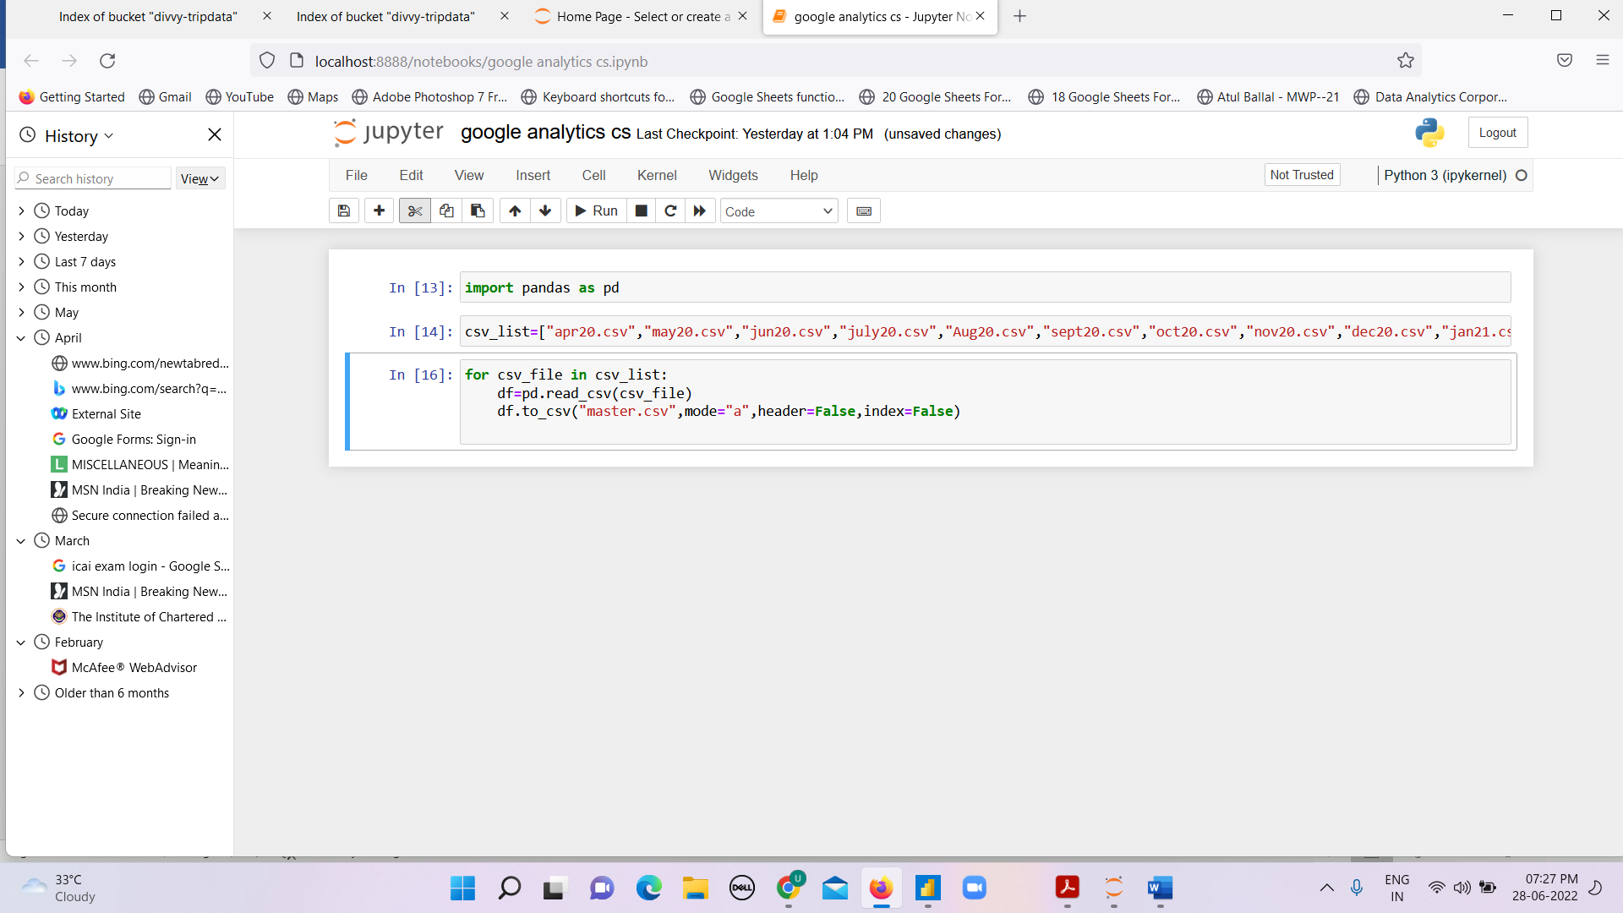

So I named 12 months data according to their month and year respectively. I used pandas library ,thereafter I imported all the files into a csv_list and then I used a loop within the list which will print all the values of those 12 files into the master file without any header and index since we already have header and index in the master file.

Now our master file is created which has about 3.5 million rows into it. This is a huge data hence Microsoft Excel is not an ideal choice for us to do the further analysis. So we shift to Microsoft PowerBI.

So now we launch **PowerBI** and **import** the master file into it. Then we have to clean the data and also add some additional columns required for our analysis,so we click the option of **Transform Data** and we reach the editor panel of PowerBI. Now we will remove the non-important columns like start_lat, start_long, end_lat, end_long and introduce new columns like name of the day on the given date, the ride length based on the start time as well as end time. Also we’ll check the accuracy % is 100 or not ,if it’s not 100 then we’ll further clean our data and remove the errors. We can further come back and make changes in the data whenever we wish to do it.

Now click on **Close and Apply** button to save the changes and go back to the main panel to make the visualizations.While making the visuals we have to keep in mind multiple factors and should be made such that they should be sophisticated and polished in order to effectively communicate to the executive team. We can use **R-Studio** instead of Python libraries for data cleaning,merging and other operations before making the visualizations. I used Power-Bi software here for making the visuals but other platforms like Tableau and Google studio are also available for completing the purpose.

Now we can start the analysis. Few important points to be taken care of are that the visualizations should be easy to understand, the colors should be chosen correctly, important things and numbers should be visible clearly and should be highlighted if necessary. Overall if we say in bunch they should contribute to our purpose of making the visualizations and insights could be easily gathered through them.

Make sure to use different types of graphs depending upon their usage and their versatality with the data it is representing. Try to avoid use same types of graphs or charts again and again so that it should look good and should also serve the purpose.The details should be made bold or in dark color so that the figures are visible clearly. You can design your own tempelate or use the already present ones depending upon the genre of visualizations. You can also add some good background related to the topic to make it more attractive. I have designed my tempelate according to my current level of experience which I might improve in the near future based on my updated knowledge.

My dashboard template can be viewed [here](https://github.com/ujjwalwadera/Cyclistic-bike-share-analysis) .

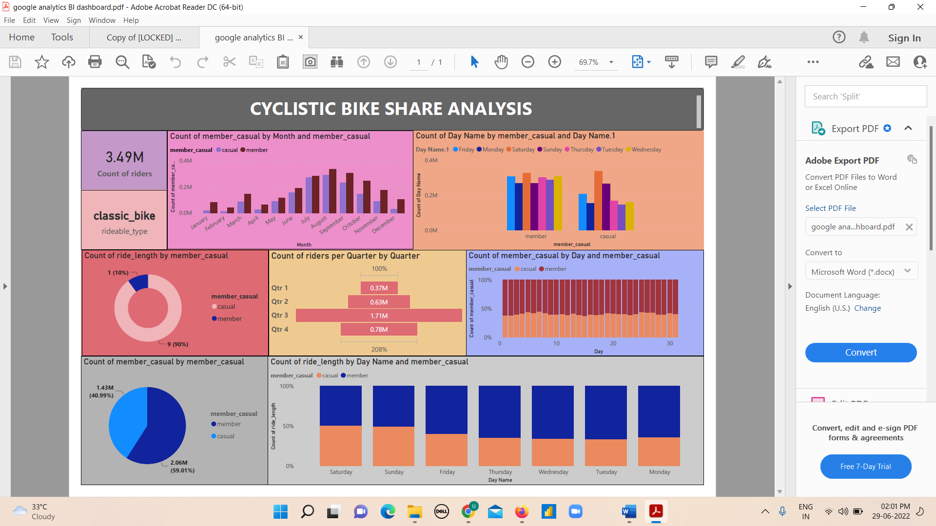

I have added my current knowledge into this dashboard and now it’s time to gather some insights from it and answer the questions we aimed.

INSIGHTS:

* From the graph between count of casuals and members VS the month, we see that in every month members are more than casuals peaking in the month of August.
* From the graph between count of casuals and members VS the day, we see that Casuals are more on Saturday and Sunday whereas members are more on the week days.
* When we analyse the donut chart which is between ride length VS casuals and members, so we see that casuals cycle for more time than the members.
* From the funnel chart which is between the 4 quarters of the year and riders, we see that the riders are the most in the 3rd quarter that is in the months of

July, August and September.

* From the pie chart, we can see that approx. 60% of the people are our members and 40% are casuals.
* And last but not the least, the stacked bar chart between ride length and riders show that casuals drive more length on Saturdays and Sundays.

Conclusions and Suggestions:

* From the graphs, we conclude that if the company wants to convert casual riders to members, then they should focus on the peak season and that to on the weekends. They can conduct some small seminars or can appoint some executives who can talk to the casuals, tell them the benefits of the membership.
* They can focus on offering some discounts for the casual customers for memberships or referral plans for existing members to invite the casual members to take the membership.
* They can focus on the peak months those are July, August, September and offer the best deals whereas in the months where the riding is very low i.e. in Dec, Jan, Feb which are the months of winter, we can offer them jackets or mufflers along with the yearly subscription to attract the public and boost their sales.
* The sales are much affected by the season and hence the marketing team should focus on developing different strategies according to the month.
* If more data is provided about the age group which use cyclistic’s bikes, we can focus on the particular segment of people and come up with more innovative ideas.